Angel Almanzar
Professor Termini
Intro to Linux
3/11/2025

#!/bin/sh #identifies the script so the commands can run. This is called a shebang.
echo hello world #prints hello world .

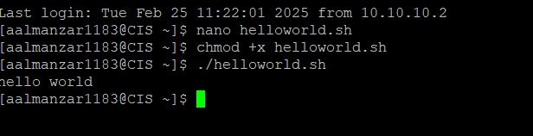

#Angel Almanzar
#!/bin/sh #this is a shebang, lets the system know it is a script.
name=angel #setting the name variable to my name.
echo this is plain text. #echo without quotes is plain text.
echo "hello $name this is semiopaque" #echo with double quotes, is semi opaque and will use variables.
echo 'hello $name this is opaque' #this is a echo with single quotes, and will show you exactly what you write in the quote and will not use variables.

